**Georgia Institute of Technology**

The George W. Woodruff School of Mechanical Engineering

Nuclear & Radiological Engineering/Medical Physics Program

Ph.D. Qualifier Exam

Spring Semester 2016

______________ Your ID Code

**Radiation Detection/Dosimetry (Day 2)**

Instructions

1. Use a separate page for each answer sheet (no front to back answers).
2. The question number should be shown on each answer sheet.
3. ANSWER 4 OF 6 QUESTIONS ONLY.
4. Staple your question sheet to your answer sheets and turn in.

**NRE/MP Radiation Detection/Dosimetry**

**Answer any 4 of the following 6 questions:**

Q1. It has been reported that in 2006 a former Russian spy, Mr. Alexander Litvinenko, was poisoned to death three weeks after drinking a glass of 210Po-containing soda. Mr. Litvinenko’s appearance clearly showed that he died of the acute radiation syndrome. Based on the three weeks of time between when he drank the soda and when he died, it was estimated that his whole-body absorbed dose was about 4 Gy. Use the following data/ assumptions to calculate the amount of 210Po (in micrograms) that was ingested by Mr. Litvinenko.

Data: (1) The ingested 210Po is fully absorbed and uniformly distributed in the soft tissue of his body, and there was no excretion of 210Po from the body since ingestion.

(2) Mr. Alexander Litvinenko weighed 70 kg, of which 70% is made of soft tissue.

(3) 210Po has a half-life of 138 days. it is a pure alpha-emitter emitting one 5.4-MeV alpha particle per decay.

Q2. Fano factor is a quantity that is involved in describing the energy resolution of a high-purity germanium (HPGe) detector

(a) Define the Fano factor.

(b) Design an experiment to determine the Fano factor of a HPGe detector, and explain step-by-step how it is determined. Use graphics if necessary.

Q3. Refer to the figure below. A collimated gamma-ray beam is brought to perpendicularly incident on a sheet of unknown material. A G-M counter is used to detect the gamma rays with and without the material in place. Assume that the count rate varies with the material thickness exponentially, i.e.



where *t* is the material thickness, μ is the linear attenuation coefficient, and *c*0 is the count rate when the material is removed. If the material thickness is exactly 1 mm thick (with no error at all), and *c*0 and *c* obtained from the G-M counter are 10000 counts and 5000 counts, respectively, calculate μ and its standard deviation σμ.

G-M counter

1 mm

Gamma rays

Q4. In a Compton scattering experiment (see the figure below), a well-collimated 662-keV gamma-ray beam is brought to perpendicularly incident on a small 1 cm-thick aluminum plate. The scattered photons are being measured at 45° angle with a 2"x2" NaI detector. Use the data given below to estimate the probability for a scattered photon entering the NaI detector.

Data: (1) the incident beam intensity is 1.0x105 photons sec-1,

(2) the linear attenuation coefficient of aluminum for 662 keV photons is 0.2 cm-1,

(3) the distance between the aluminum plate and the NaI detector is 50 cm,

(4) the total photopeak counts recorded by the NaI detector is 10,000 in 5 minutes, and

(5) the intrinsic peak efficiency for the NaI detector can be determined from the data provided in Appendix A.

1 cm

45o

Aluminum plate

2”x2” NaI

A narrow beam of 662-keV photons

Scattered photon

Q5. A 10-MeV gamma-ray enters a volume V and then undergoes triplet production.

* 1. Define triplet production. What is the threshold of the reaction?
  2. Assume that the energy not used for the reaction is evenly divided among all charged particles. Negatively-charged particle(s) spend half of the kinetic energy in collision interactions before escaping from V. Positively-charged particle(s) fully stop and then annihilate with an electron. Annihilation photons escape from V. Calculate energy transferred and energy imparted.

Q6 You are tasked to determine the dose associated with a beam of 14-MeV neutrons produced by the DT generator in the RSEL.

* 1. Explain the difference between broad- and narrow-beam geometry and attenuation of uncharged radiation (total of four scenarios to discuss).
  2. Figure below shows changes in the beam attenuation as a function of beam parameters (broad vs. narrow) in steel. Qualitatively, discuss what happens to the beam between A, B, C, and D scenarios (note that they do not necessarily correlate with scenarios in part (a) of this question). Use the insert to help explain the beam attenuation features.

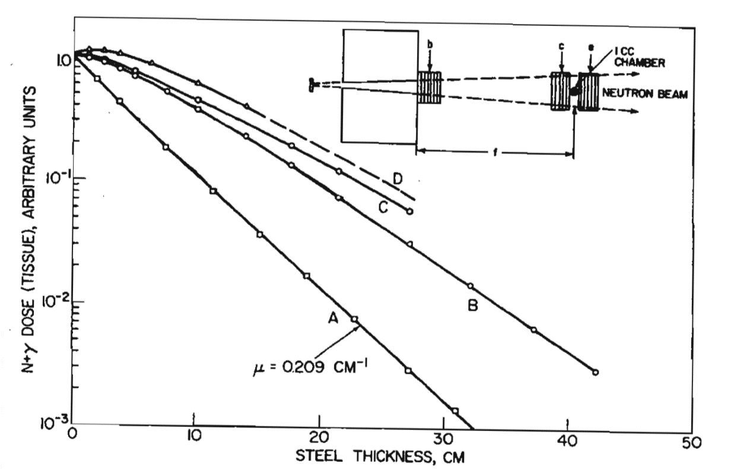

**APPENDIX A**





Peak-to-total ratio