**Georgia Institute of Technology**

The George W. Woodruff School of Mechanical Engineering

Nuclear & Radiological Engineering/Medical Physics Program

Ph.D. Qualifier Exam

Fall Semester 2017

______________

Your ID Code

**MP Therapy and Imaging Physics**

**(Day 2)**

Instructions

1. Use a separate page for each answer sheet using only the front side of the paper. DO NOT write on the back of the answer sheet.
2. The question number and your ID Code should be shown clearly on each answer sheet
3. **ANSWER 2 OF 3 Questions in each section; you will have answers for 2**

**Therapy questions and 2 Imaging Physics questions**

4. Staple your question sheet to your answer sheets and turn in

**MP Therapy**

**Answer any 2 of the 3 questions** **in Therapy**

**Question 1:**

Write the TG-51 equation for a 6 MV beam. Describe each term including all

correction factors. Write equations for correction factors if applicable.

**Question 2:**

A 21 cm wide patient is to be treated at midline with an opposed pair of

isocentric 6X fields. The field sizes at isocenter are 12.6 x 17.0 cm. How many

MUs per field are required to deliver 3 Gy total? (*Use calc book factors below.)*

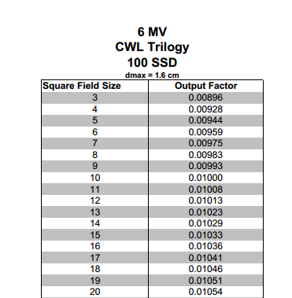

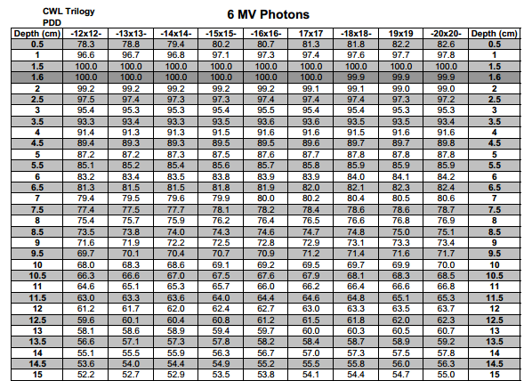

**Question 3:**

Explain the principles of a standing wave accelerating waveguide. How can this

waveguide be used to create low and high energy photons?

**MP Imaging Physics**

**Answer any 2 of the 3 questions** **in Imaging Physics**

**Question 4:**

Consider a PET scan of a 40-cm-dia. spherical soft-tissue object located at the center of

the 90-cm-dia ring. A Fluorine-18 source is placed at the center of the object to calibrate

the sensitivity (in cps/μCi) of the PET system. Given that the attenuation coefficients for

soft tissue and detector for the 511-keV photons are respectively 0.1 cm-1 and 0.5 cm-1,

that the thickness of the detector (i.e. the crystal) is 2.5 cm, and that the total surface area

of the detector is 5x103 cm2, calculate the expected sensitivity of the PET system. Data:

1 μCi of Fluorine-18 emits 3.6x104 positrons sec-1.



**Question 5:**

The following questions refer to ultrasound.

a) 3MHz pulsed Doppler transducer is used to image the blood flow velocity in a stenosis (narrowing) in a blood vessel. The velocity vector is at a 60 degree angle to the beam, and 3 cycles of the fundamental frequency are transmitted. If the stenosis is a 50% area reduction and the velocity before the stenosis 100 cm/sec, what is the PRR at which aliasing occurs in the stenosis?

b) If the echo from the vessel was received 65 microseconds after the pulse reflected from the vessel, at what depth is the vessel located? How would this change if a 5 MHz transducer was used?

**Question 6:**

The following questions refer to MRI. Use γ = 42.5 [MHz/Tesla]

a) What is the Z-position from the iso-center of the scanner of a signal with ω = 21.21 MHz and Gz = 40 milliTesla/meter if the scanner is a 0.5 Tesla scanner?

b) What would be the frequency of a proton located in the x = 40, z=0, y=0 cm position with gradients of Gx = 40 milliTesla/meter, Gy = 10 milliTesla/meter and Gz = 20 millTesla/meter at 3.0 Tesla.?

c) How much longitudinal magnetization is present in fat 100 milliseconds after a 60˚ RF pulse in terms of the equilibrium magnetization M0? Assume T1 of fat is 260 milliseconds and T2 of fat is 85 milliseconds.