Georgia Institute of Technology

The George W. Woodruff School of Mechanical Engineering
Nuclear & Radiological Engineering/Medical Physics Program

Ph.D. Qualifier Exam
Fall Semester 2015

______________ Your ID Code

Detection and Dosimetry (Day 2)

Instructions

- Use a separate page for each answer sheet (no front to back answers)
- The question number should be shown on each answer sheet
3. ANSWER 4 OF 6 QUESTIONS ONLY
4. Staple your question sheet to your answer sheets and turn in

NRE/MP Detection and Dosimetry

Answer any 4 of the following 6 questions.

Question 1.

(a) Define the Bragg-Gray conditions. Discuss the differences in how these conditions will hold for photon vs. neutron fields.
(b) Suppose we have a 1 cm radius cavity of a polystyrene-based scintillation dosimeter (density of 1.06 g/cm3) embedded in water (density of 1.0 g/cm3). What is the ratio of dose between the dosimeter and the water for a 1.5 MeV photon beam? (ignore attenuation)

Question 2.

(a) You are considering proton and deuteron beams for a tumor treatment. The goal is to maximize particle energy deposition in tumor tissue. The beam modalities are 300 MeV protons or 600 MeV deuterons. Which deposits more energy per unit length in tissue (per particle)?
(b) At what energies radiative yield becomes important (e.g. 50% of energy loss) for protons and deuterons?
(c) In the discussion of charged particle stopping power, shell correction term may become important. Briefly define the correction term and its physical origin. Discuss how (if) it changes in the stopping power equation for protons vs. electrons of the same velocity.

Useful tables

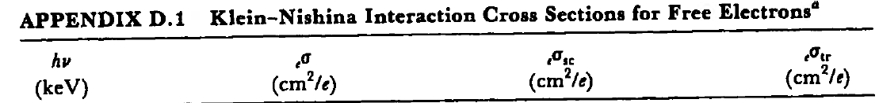
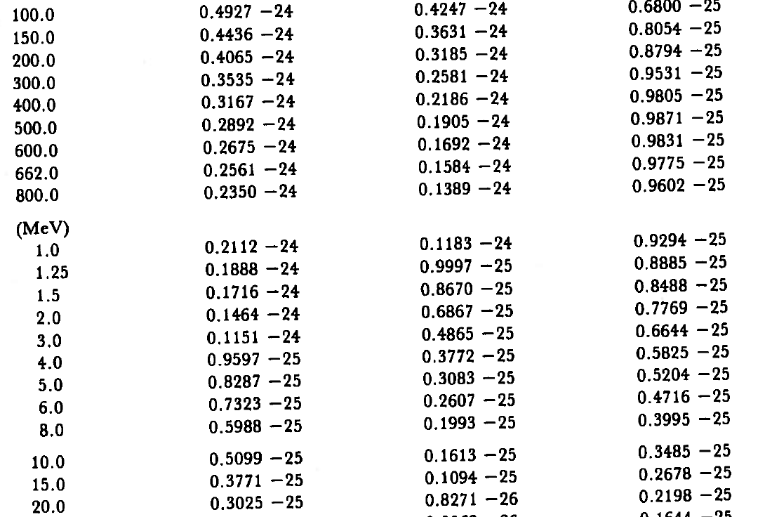
Electrons in polystyrene

Question 3.
- A liquid scintillation counter is calibrated so that a low-energy window (window 1)has a counting efficient of 30% for ³H and a higher-energy window (window 2) has a counting efficient of 72% for ³²P. When a ³²P standard is counted, it is noted that 12% of the number of counts in window 2 are recorded in window 1. A mixed sample containing ³H and ³²P yields 3800 counts in window 1 and 5800 counts in window 2. Determine the activity of each radionuclide.
- The gross count rate of a weak 60Co source is estimated to be 54 counts per minute with a counting system that has a 10 counts per minute background. IF one hour is allocated for counting the source and the background, calculate the optimum counting times for each.
- Four aliquots of a sample were measured with count rates and respective standard deviations of 953, 10510, 946 and 11812. What is the sample mean and its standard deviation?

Question 4.
Calculate the following total doses for internal intakes of Co-60. You may treat two Co-60 gamma rays as both being emitted at 1.25 MeV. The physical half-life of Co-60 is 5.27 years.The mass of the whole body is 70 kg and of the lungs is 1.5 kg. The b
  - The photon dose to the lung for 37kBq of Co-60 deposited in the lung and cleared with a biological half-life of 60 days.
  - The photon dose to the whole body for 37kBq of Co-60 deposited in the lung and cleared with a biological half-life of 60 days.
  - Calculate the photon dose to the lung for 37kBq of Co-60 uniformly deposited in the whole body that clears with a biological half-life of 800 days.
  - Calculate the total photon dose to the whole body for 37kBq of Co-60 uniformly deposited in the whole body that clears with a biological half-life of 800 days.

Question 5.
As a quality assurance procedure of an aluminum sheet production plant, the thickness of nominal 1-cm sheet aluminum is to be monitored by noting the attenuation of a gamma-ray parallel beam passing perpendicularly through the sheet. The source and detector are well shielded, so background and scattering into the detector are negligible. Any given sample spends 1 s in the beam. The detector counting rate with no sheet in place has a mean value of 10,000 per second (measured over a long time, and therefore has a negligible error).
(a) Find the optimum value of linear attenuation coefficient µ that will minimize the uncertainty in the derived sheet thickness.
(b) What is the lowest achievable uncertainty (i.e. one standard deviation) for the sheet thickness?

Question 6.

Discuss the pros and cons of the following three types of gamma spectrometers: HPGe, CZT, and LaBr.

