**Georgia Institute of Technology**

The George W. Woodruff School of Mechanical Engineering

Nuclear and Radiological Engineering/Medical Physics Program

PhD Qualifying Exam

Fall 2019

___________

(Your ID Code)

**Nuclear Engineering**

**Radiation Detection and Protection**

**(Day 2)**

**Instructions**

1. Use a separate page for each answer sheet using only the front side of the paper. DO NOT write on the back of the answer sheet
2. The **question number and your ID Code** should be shown clearly on each answer sheet
3. **ANSWER 2 OF 3 Questions in each section; you will have answers for 2 Radiation Detection questions and 2 Radiation Protection questions**
4. Staple your question sheet to your answer sheet and turn in

**Radiation Detection**

**Detection Question 1.**

A silicon p-n junction is operated at room temperature (300K). If the acceptor concentration is 1016 cm-3, and the donor concentration is 1012 cm-3, calculate the following:

* 1. Built-in voltage;
  2. Potential across the depletion region at an applied voltage, Va, of 0, 0.5 and -2 Volt;
  3. What is the corresponding widths of the depletion region for the applied voltages in (b)?

Useful constants and parameters:

Boltzmann constant = 1.38x10-23 m2-kg-s-2-K-1 = 8.617×10−5 eV-K−1

At 300K, the number of intrinsic carriers in Si is 1.45x10^10 cm^-3

Electron charge = 1.6x10-19 C

Dielectric constant = 11.7

Permittivity of free space e0 = 8.854 x 10-12 Farad/m

**Detection Question 2.**

Refer to the decay scheme of 137Cs below and propose a detection system that can be used to accurately measure the branching ratios for both the gamma decay and the IC, respectively, for the transition from 137mBa to the ground state. Please first describe the system (including the type of detector and the data acquisition system) and then described the steps needed to achieve the intended measurement goal.

IC

γ

137Cs

137mBa

137Ba

β1

0.662 MeV

Ground

**Detection Question 3.**

In a Compton Scattering experiment (shown below), a well-collimated 1-MeV gamma-ray beam was brought to perpendicularly incident on a 1cmx1cm square aluminum rod. The scattered photons were being measured at 60° angle with a 2"x2" NaI(Tl) detector located at some distance away. Given that: (1) the incident beam intensity hitting the aluminum rod was 1.0x105 photons sec-1, (2) the linear attenuation coefficient of aluminum for 1-MeV photons is 0.2 cm-1, and (3) the total counts recorded by the NaI(Tl) detector was 10,000 in 5 minutes, estimate: (a) the number of photons that underwent Compton scattering with the aluminum rod in 5 minutes, (b) the energy of the scattered photons entering the NaI(Tl) detector, and (c) the probability for a scattered photon to enter the NaI(Tl) detector.

Note: you need Attachment A for this problem.

PMT

60o

Aluminum rod

2”x2” NaI

Incident beam of 1-MeV photons

Scattered photons

Attachment A



Plots of the intrinsic total efficiency for sodium iodide scintillators of various thicknesses.

**Radiation Protection**

**Protection Question 1.**

Terrorists detonate an improvised nuclear device which has a 15-kiloton yield, i.e. the blast is equivalent to 15,000 tons of TNT. One kiloton is the result of 1.45(1023) fissions. In this case we assume that the fissile material is U-235. (Use 200 MeV per fission - of course this is a number that any good nuclear engineer should know!) The yield of I-131 from fission of U-235 is 2.83%. The half-life of 1-131 is 8.02 days.

1. How much I-131 (Bq) is produced at the instant of the explosion?
2. How long would a reactor operating at 3300 MW(thermal) have to operate (days) before it contains the same activity of I-131 in its fuel inventory?
3. 10-6 of this amount of I-131 is released into a warehouse that is 50 m x 30m with a height of 15 m. Assume the I-131 is instantaneously mixed in the air volume of the building and that there are 3 building air exchanges per hour with uncontaminated air via the air conditioning system. What thyroid dose would a person receive if they spent 30 minutes in the building immediately following the release? Assume the person was just sitting in the building and his/her breathing rate was 10 liters per minute. The thyroid dose coefficient for inhalation is 2.92(10-7) Sv/Bq.

**Protection Question 2.**

A nuclear bomb is exploded at an altitude of 600m. Assume that there were 3(1024) fissions in the explosion. Neglect the shielding effect of the air and scattering from the ground.

* + - 1. If there are on the average 6 prompt gammas released per fission at 1 MeV. What is the prompt gamma-ray dose at 1500 m downfield from the explosion?
      2. If 2.5 prompt neutrons are emitted per fission at an average energy of 2 MeV, what is the neutron dose at the same point?
      3. If 0.01% of the fission products are attached to a particle is deposited at a location downfield, what bulk fission product activity remains on the particle one week after the detonation assuming that the only mechanism of removal is decay?
      4. What is the gamma-ray dose you would receive 1 m from the particle containing fission products if you sat next to it for a day starting on the eight day after the detonation? Assume that the average fission product gamma energy per decay is 0.7 MeV.

**Data: Fluence-to-Ambient Dose Equivalent Conversion Coefficients**

|  |  |
| --- | --- |
| 1 MeV gammas | 5.2 pSv-cm2 |
| 0.7 MeV gammas | 3.9 pSv-cm2 |
| 2 MeV neutrons | 420 pSv-cm2 |

A single fission results in an activity of 3.81(10-6)t-1.2 Bq/fission as a function of time in days after the fission.

**Protection Question 3.**

In the year 2000, woodcutters in the nation of Georgia found “warm” canisters in a very remote region. They camped near these canisters to keep warm in the winter. It turns out these canisters were old 90Sr thermoelectric generators. The woodcutters ended up in the hospital with radiation poisoning.

90Sr is a pure β emitter to 90Y. 90Y decays to 90Zr which is stable.

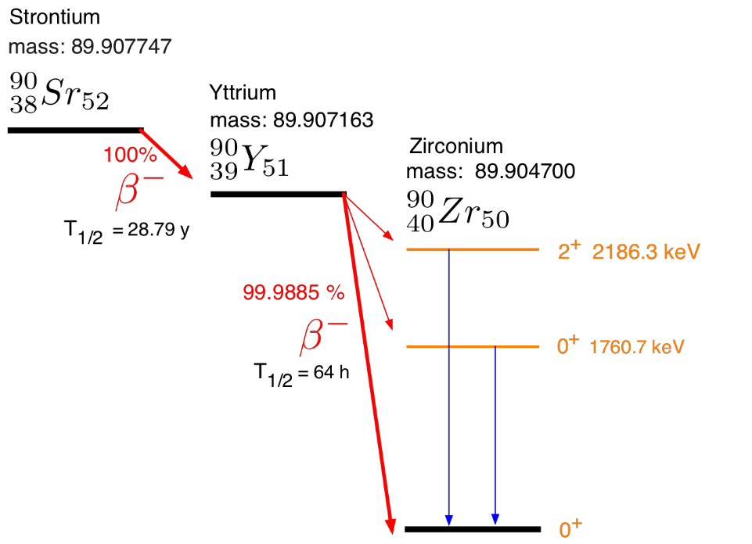

1. In principle, how does a thermoelectric generator work? With a few sentences, explain how to obtain electricity from the decay of .90Sr.
2. Design a simple shield for 90Sr given the above decay information? Provide a drawing with approximate thicknesses and materials labeled (no calculations necessary). Justify choices.
3. If you assume the thermoelectric generator had shielding sufficient to stop all the β- particles, what was the dominant mechanism that caused appreciable dose to the woodcutters?